

**Weekly Newsletter** 15/02/2019

4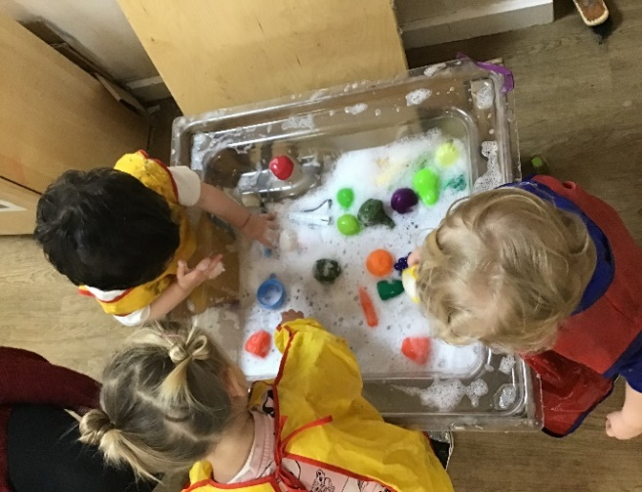

**Hi all, do you have any old wellies that we can have? Please give them to a member of staff…**

**Children’s Menu**

**The menu is due to change and we are asking all parents to think about what they would like their children to eat and either email or why not go over and say hello to Santi and give him your suggestions personally?**

**We all know Santi is a very good chef and he would like to showcase all the new and exciting meals that are on offer!**

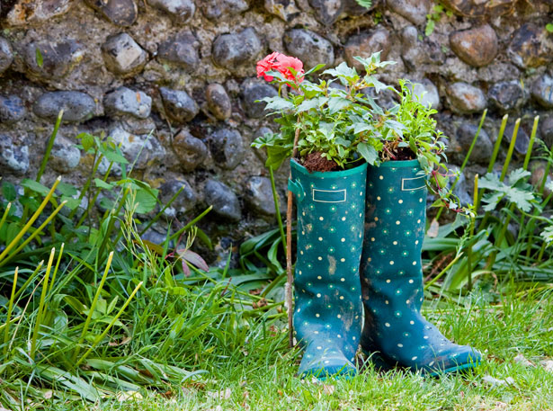



The 2-3’s enjoyed washing the play food

***Happy Birthday.***

***Mia R***

Happy Valentine’s Day

The preschool made lovely pink and red playdough as well as decorated cards and flowers.



If you have changed address, phone number, emergency contacts please email the nursery with the details.