Preschool Room  Planning/Topic  In June we will be focussing on manners and life skills. Respect for the child is the cornerstone based on the EYFS (positive relationships). Practitioners show respect for children by providing them with the opportunity to do, think and learn for themselves. Through freedom of choice, children are able to develop the skills and abilities needed to become confident learners!  Also the topic for this month in preschool has been Ramadan. We have been learning about Ramadan-reading stories and participating in arts and crafts.  All about me…  The children will be discovering themselves with the help of their key worker. As the children will be transitioning to school, they will be focusing on themselves. This will involve things that they like, dislike, their families, their favorite color, a word that best describes them and what they want to be when they grow up!  We will be working in partnership with parents to ensure the children have a smooth transition to their new school.  Please bring a photograph of your family for ‘show and tell’. |  | Dates for your Diary  Eid party-Thursday 6th June (children only) the children will be celebrating throughout the day, with activities and special Eid food.  Father’s Day-stay and play (Friday 14th June), all fathers, uncles and granddads welcome to come and play between the hours of 10am-12  Graduation Day- Friday 19th July. The children will be putting on a show courtesy of Theatrebugs (who comes in on a Thursday) for you all! |  | 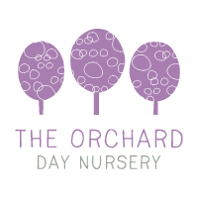  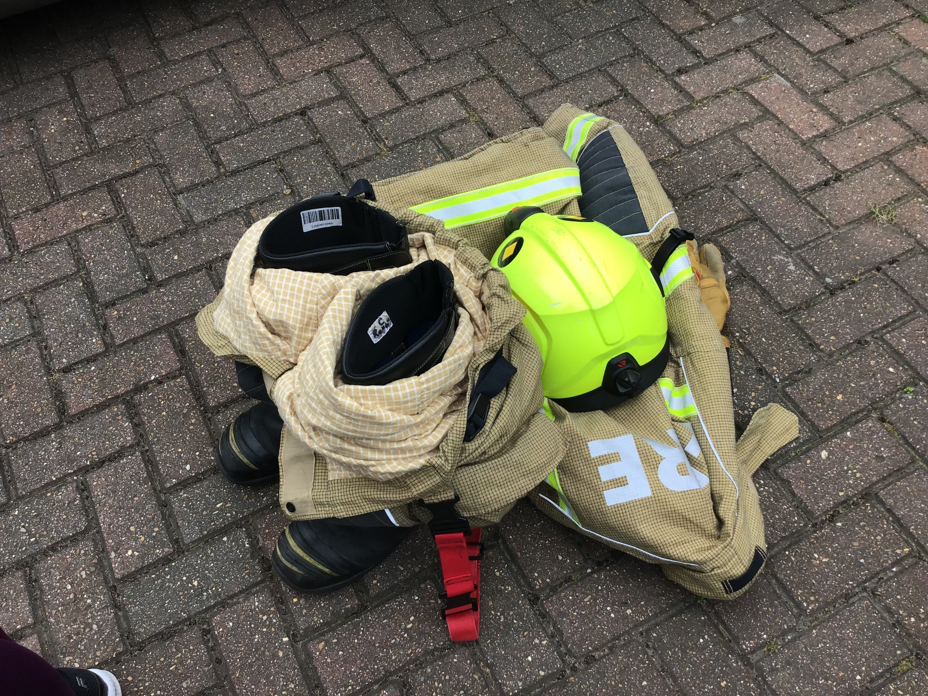  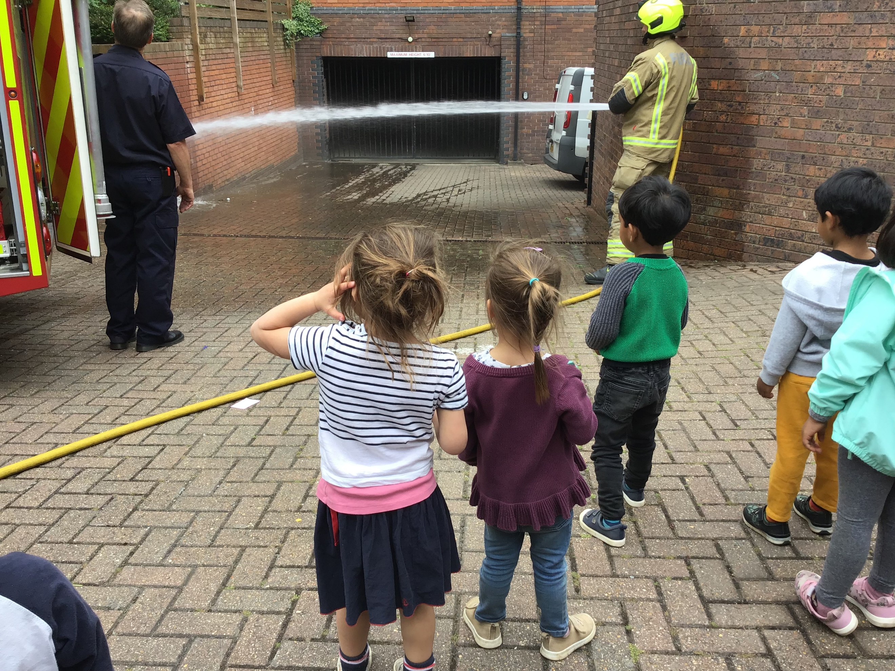  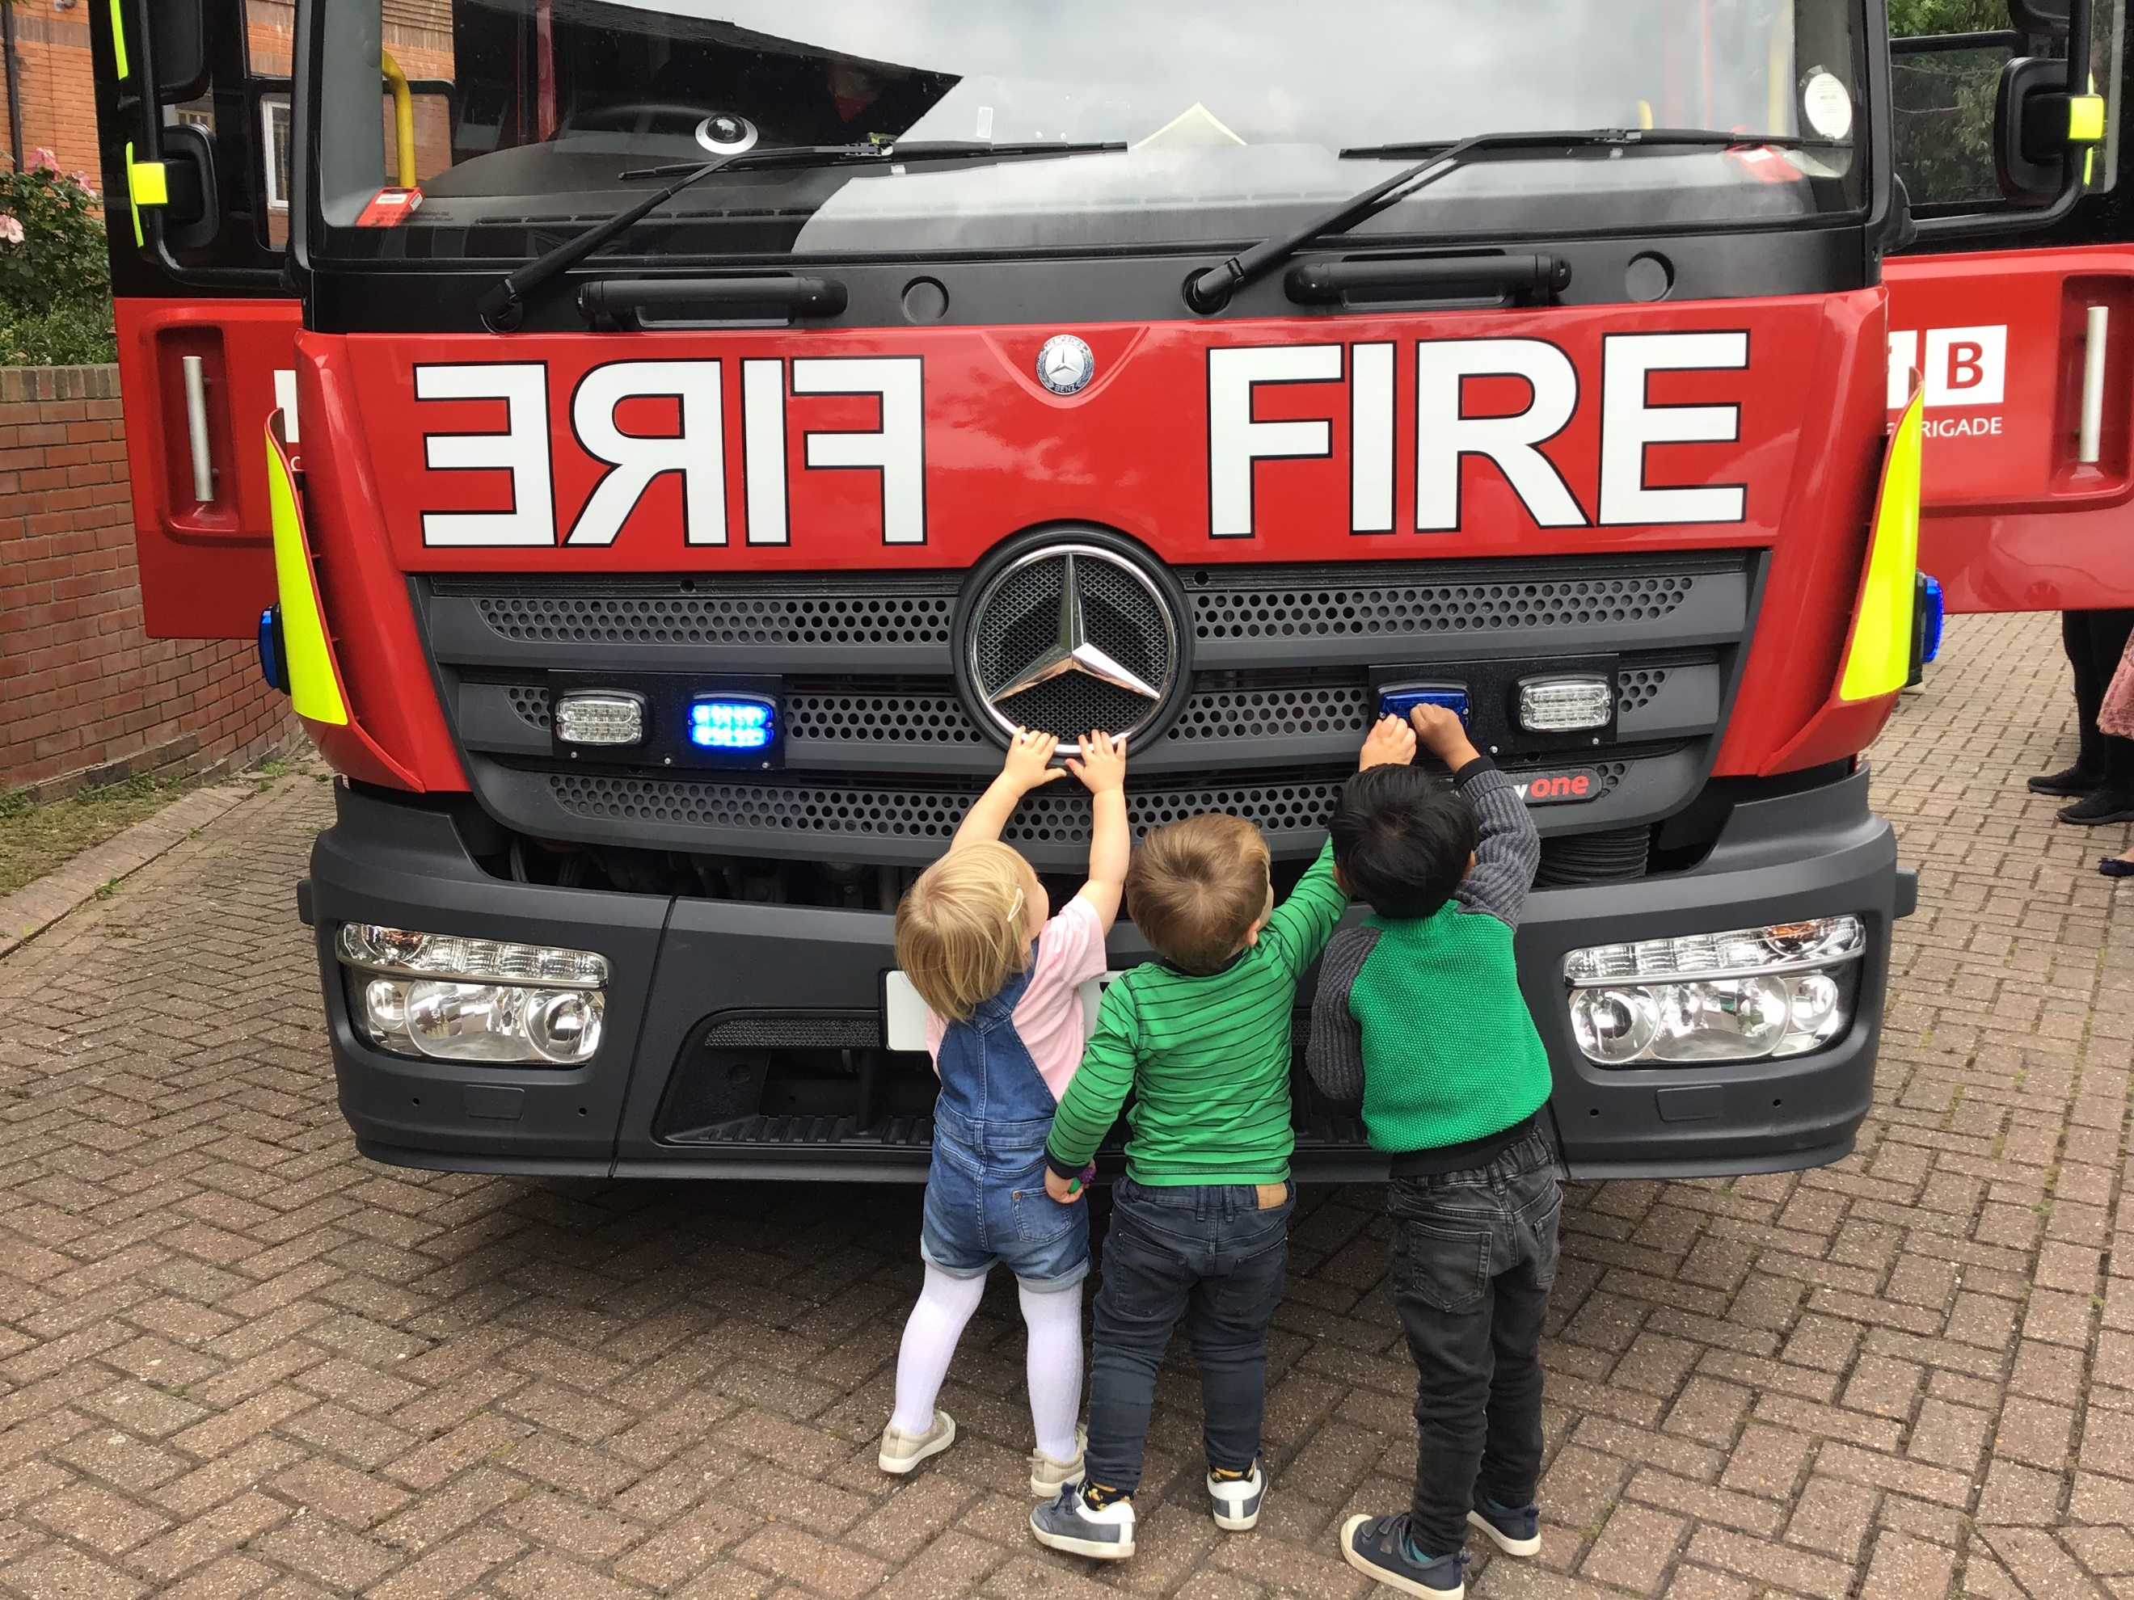  What fun the  Children (and  Parents had on  our visit from  The local Fire  Station.
 | 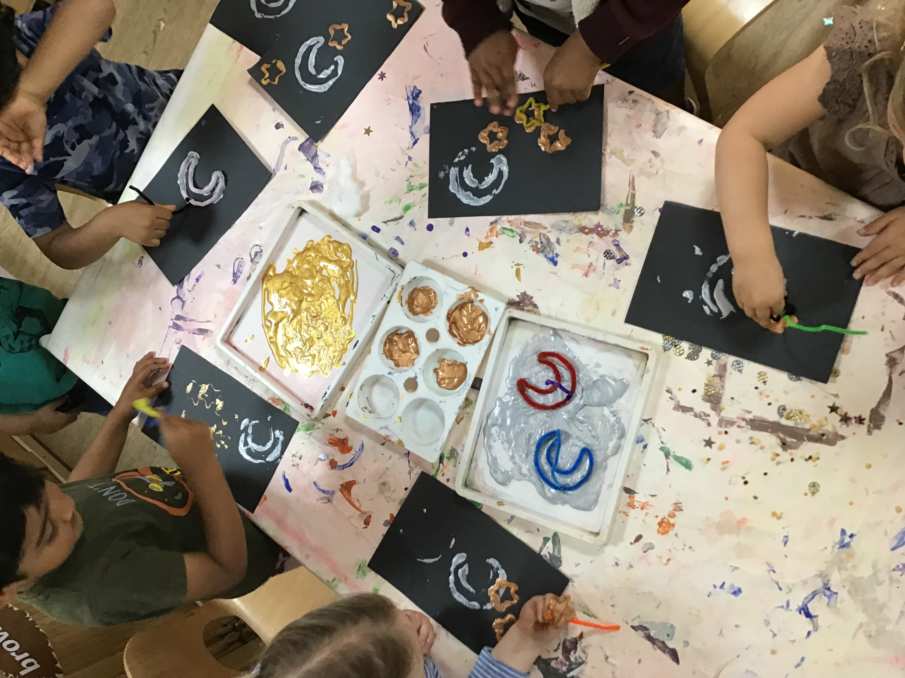

2-3’s  The children in the 2-3’s will be concentrating on sports over the next 2 weeks. Pedro from ‘sports kids’ (who come in on Monday mornings) will be teaching the children a variety of different sports, e.g. the sack race, egg and spoon and balancing. |  | Reminders  Summer Clothing-Summer is here! We have been blessed with some beautiful hot days. Please make sure that your child has the appropriate clothing and sun hats. We strongly suggest keeping 2 or 3 extra pairs of clothing items, including socks as they often can get dirty.  Sickness  Sickness -I cannot emphasize enough, parents please keep your children in the comfort of their own home when your child is sick.  Lost property - Please make sure all items belonging to the children are taken home at the end of the child’s week. The nursery will not be held liable for any items lost.  Father’s day -We are kindly reminding you that we will be having a Father’s Day ‘stay and play’ morning on Friday 14th June (all fathers, uncles and grandad’s invited)  Tapestry - is updated regularly please login and check your children’s profiles. Please add any home observations or pictures to show parent partnership. If you are having trouble logging on to your account, please see a member of staff. |  | 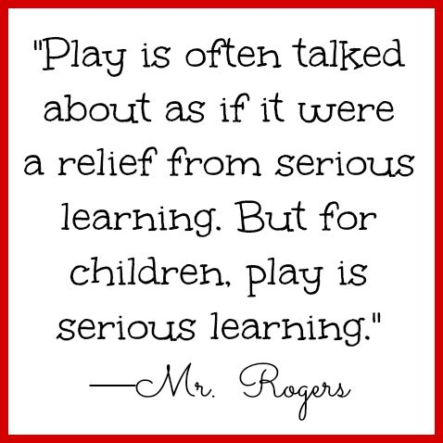
Under 2’s |  |  |  | Happy Birthday Dougie, enjoy your day
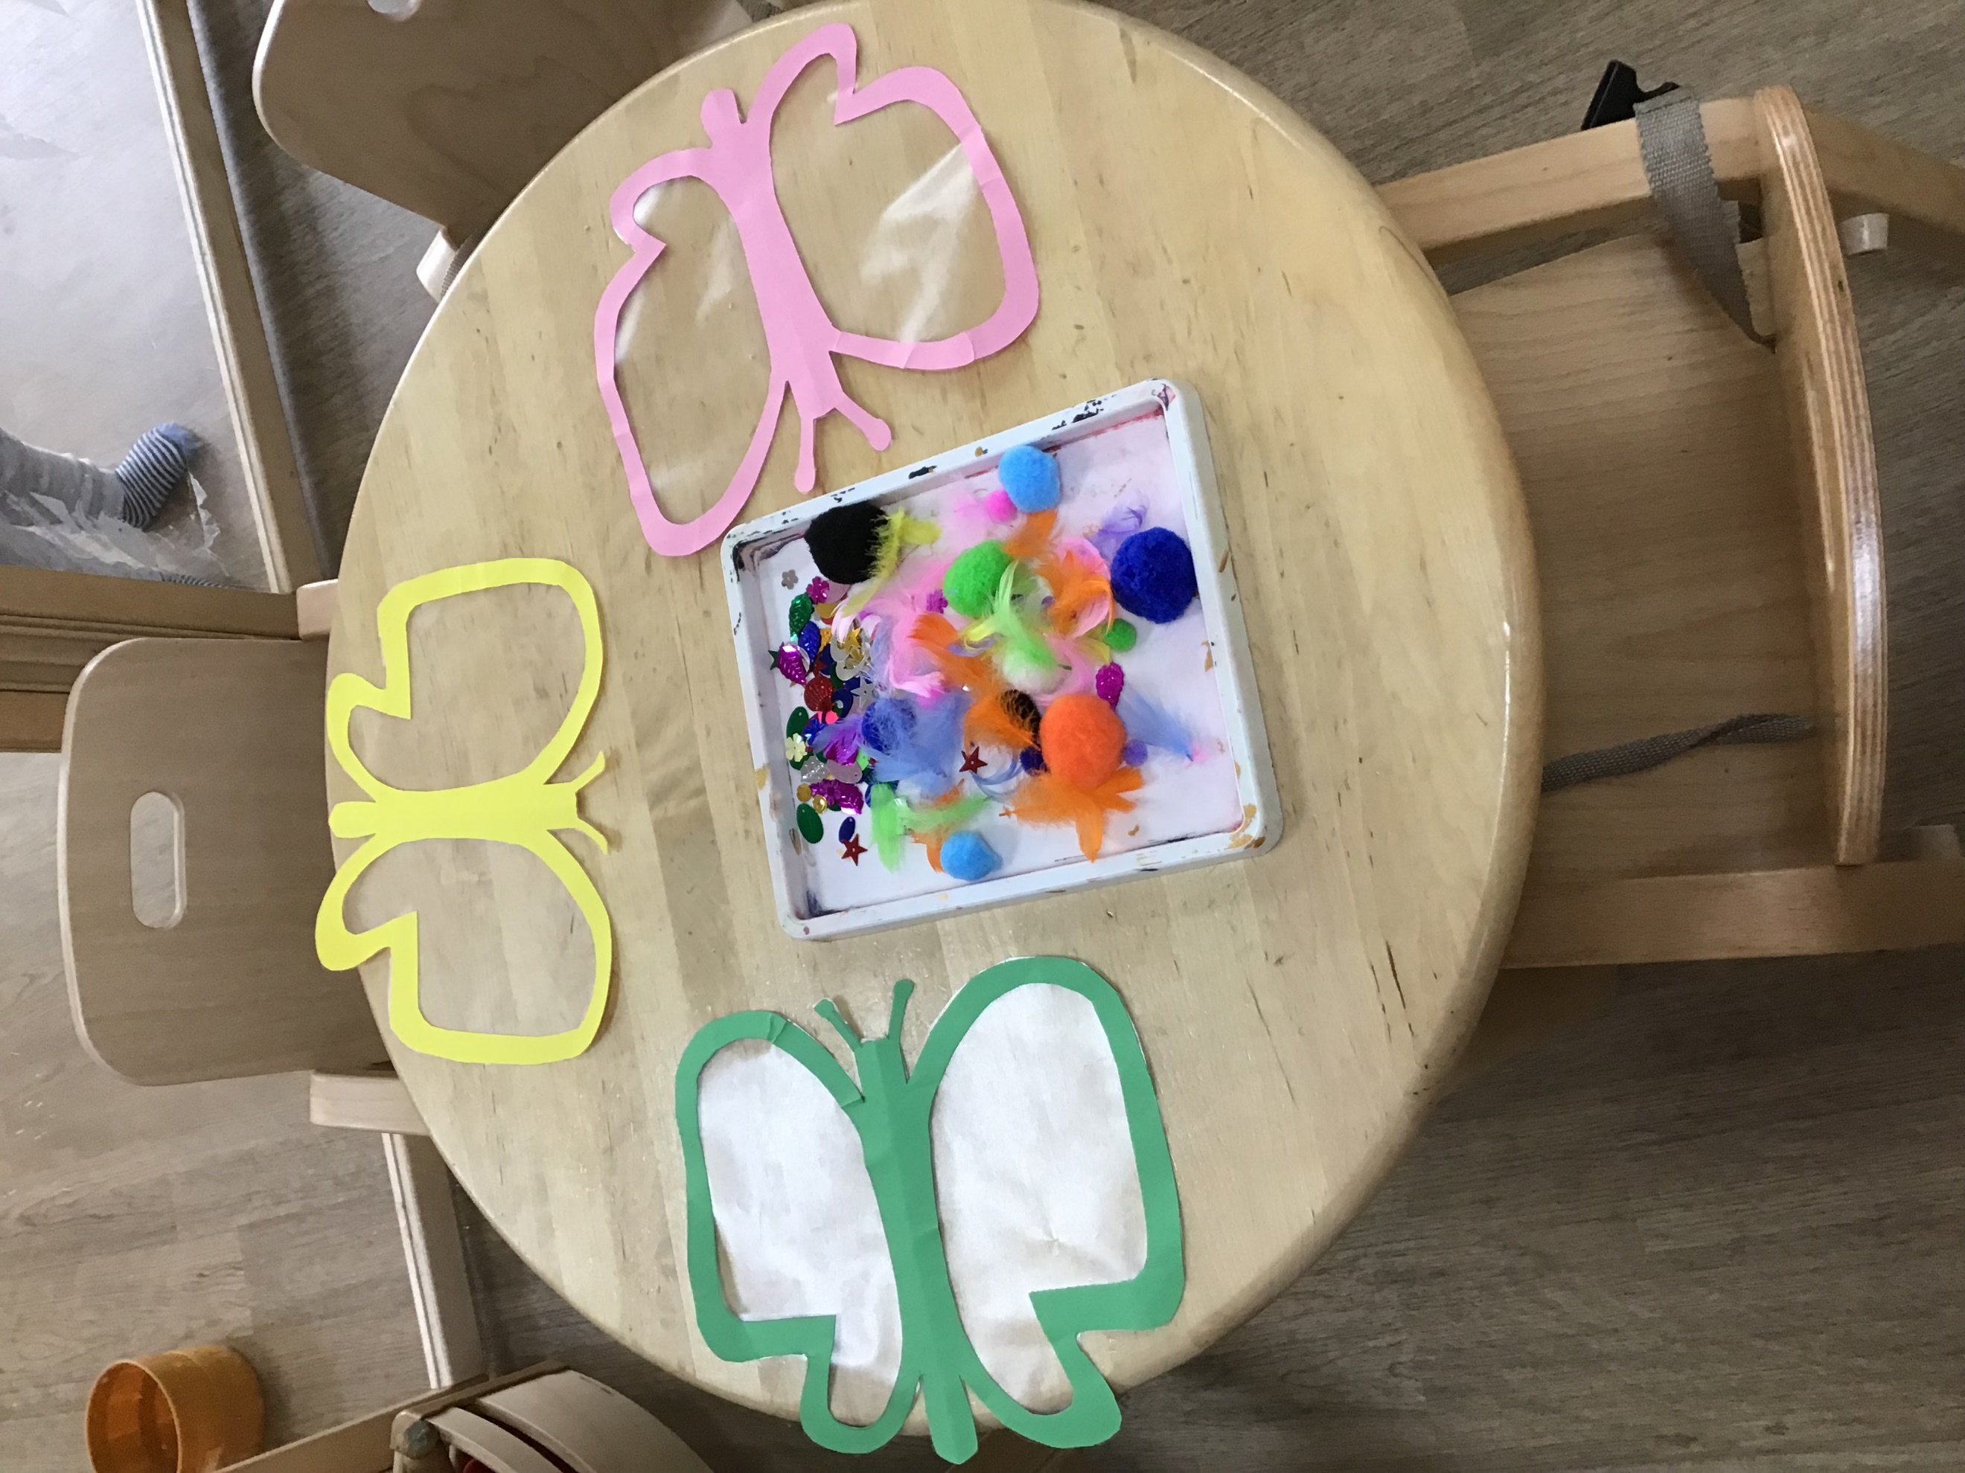  The under 2’s decorated butterflies to display on the window. They selected which materials they we’re going to use before carefully sticking them down.  We will be concentrating on physical development over the next 2 weeks, where the under 2’s will be using their large motor skills. |  |  |  | Outdoor excursions  Weather permitting, we will be taking the children out for short walks and to the local parks. All parents will be informed before any trip takes place and asked to sign the consent form. If you have any queries regarding this, please see Seemi who is based in the 2-3’s.  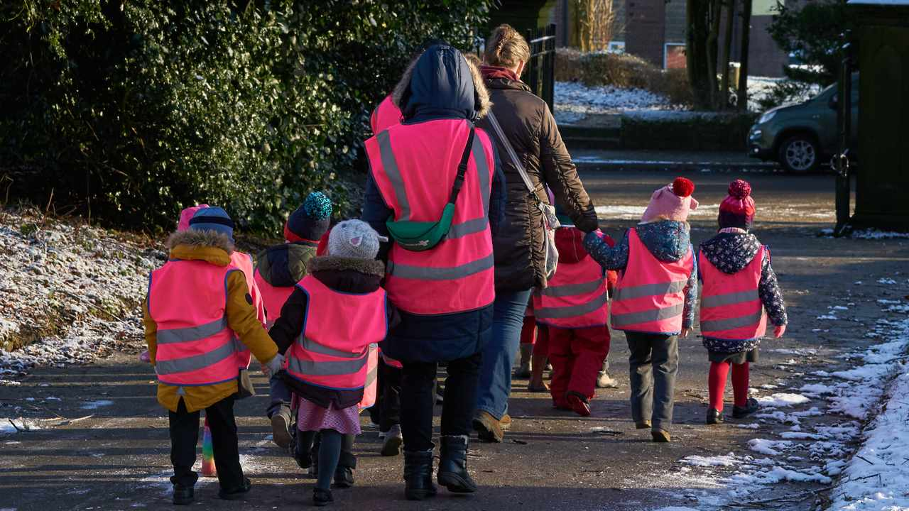
 |  | Happy June Month

