JULY/ AUGUST NEWSLETTER

In the Pre-school: The past two months have been filled with some hot weather which has excited us to continuously explore different media and materials. The garden has been filled with lots of water activities as we took advantage of the nicer weather. As the weather has been very hot these past months, we had the opportunity to bring out the sprinklers. The children enjoyed splashing around with their friends, cooling down in the sun. In Preschool room, we have been covering Sports as a Topic, we went out to watch Tennis on the big Screen. It was fun and exciting!
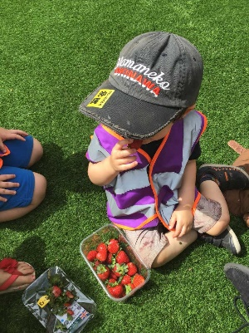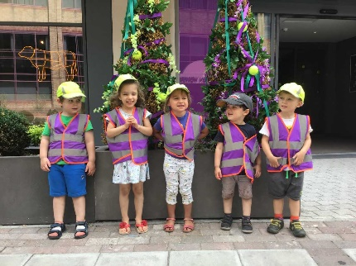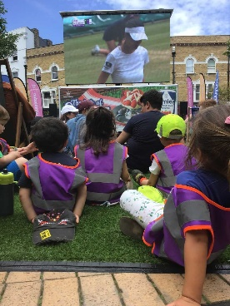

The children have also continued looking at holidays as many families enjoyed their own over the past few months. We hope you all had wonderful holidays! And welcome back to nursery!!!
In July, we had first graduation party. We celebrated children’s time spent here at The Orchard Day Nursery and sadly we had to say goodbye to some our friends who are moving on to ‘Big School’. Thank you to all the parents who came to support the children as they get ready for their next big adventure.
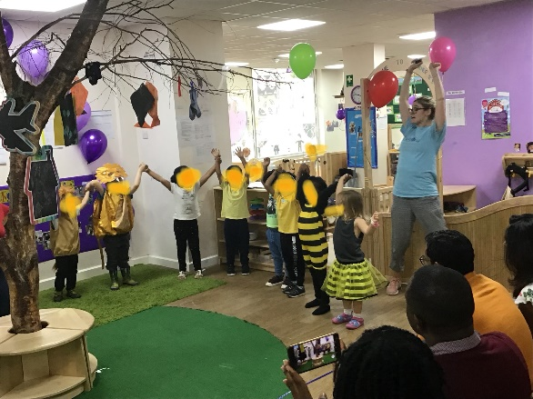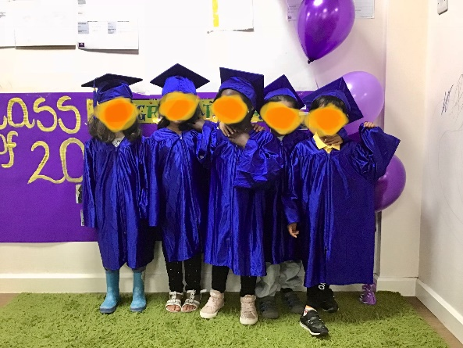

The Toddler Room continued to be busy these past months with various activities. We continued with our holiday theme, talking about favourite holiday spots, looked at the globe to see where we went on our own holidays. It was a great chance for the children to see just how far they have travelled. We also had a look at some other countries around the globe discussing where we could go or would like to go and what we could find there.

Messy play has continued, giving the children a chance to explore their senses and just get ‘messy’. We had some old favourites such as pasta and rice play, gluing and junk modelling. We had shaving foam with semolina. The older children also had the chance to experiment themselves with making different kinds of slime and glue. We experimented using different ingredients to make the slime. Some were made with water, some without. We made red, green, gold, and white slime. The children loved it and enjoyed feeling the slimy stickiness in their hands as they played with it.
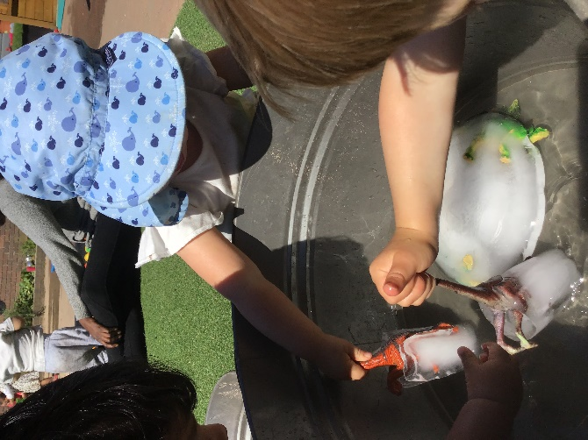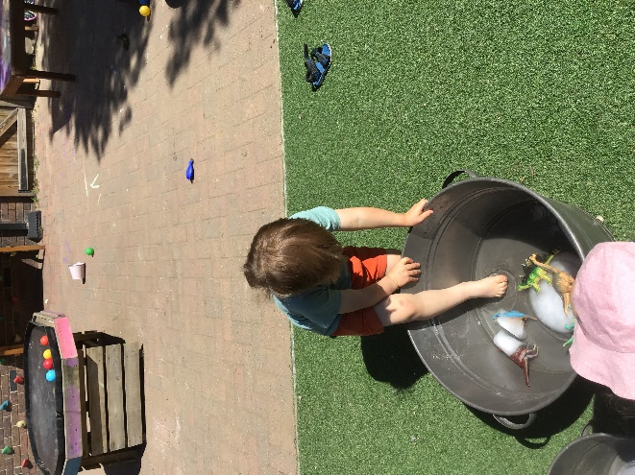

The Baby Room these past months concentrated on messy activities as they explored different textures and how one texture can be changed into another, such as cornflour. They also experimented with printing as they made different effects and patterns through sponge painting, fork painting, toothbrush painting, Lego stamping and many, many more. The children have been outside enjoying the garden equipment along with lots of water and bubble play. We also had some ice cube play which was particularly ‘cool’. The sand pit also continues to be a huge favourite amongst the little ones as it was brought into the baby room for them to do some sand stamping.
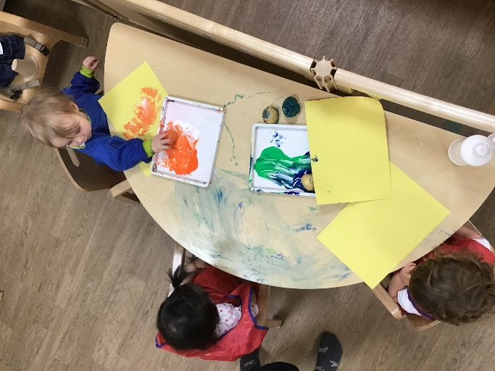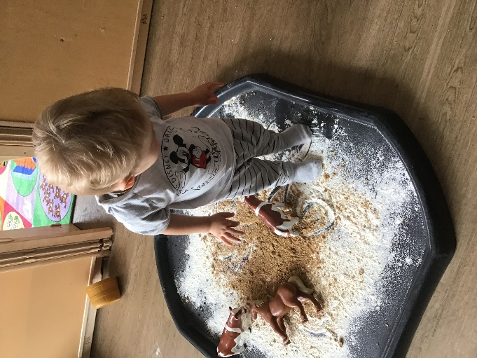

The Toddler Room would like to welcome Lukas and! Who have just moved down from the Baby Room!
We would also like to say Happy JULY Birthday to Raphael, Azaliah, Aron and Adyanth.
We would like to say a Happy AUGUST Birthday to Kaitlyn, Manuel and Ethan.
The Baby room would like to welcome Kotoha, Summer, Zorayz and Nicole
The preschool would like to welcome Kiera and Arzan

Final Notes and reminders for Parents:
- Please be aware of the policy regarding the prescribed medicines and Calpol. When administrating Calpol a phone call to the parents/carers will first be made and then the child will need to be picked up. Medications need to have the child’s name on them and be prescribed by a doctor. Please kindly remember to sign the medication form/Incident forms before you leave the building.
- We would also like to remind you that 48 hours from the last incident of any sickness or diarrhoea is the exclusion time
- Please ensure your child has plenty of change of clothes as water play will be used more as it gets hotter. And for those little toddlers who are potty training, please ensure there are plenty of change of clothes because accidents do occur.
- The baby room would also like to mention that Breakfast Time does start at 7am to 9am so please be on time if you wish your child to participate. The same goes for lunch which starts at 11:00am and tea which is at 4:00 pm.
- Please label your child’s clothing and belongings.

Have a lovely read!
Regards
Management!

